**Database specifications for EcoBike Application**

1. **ER-Diagram**

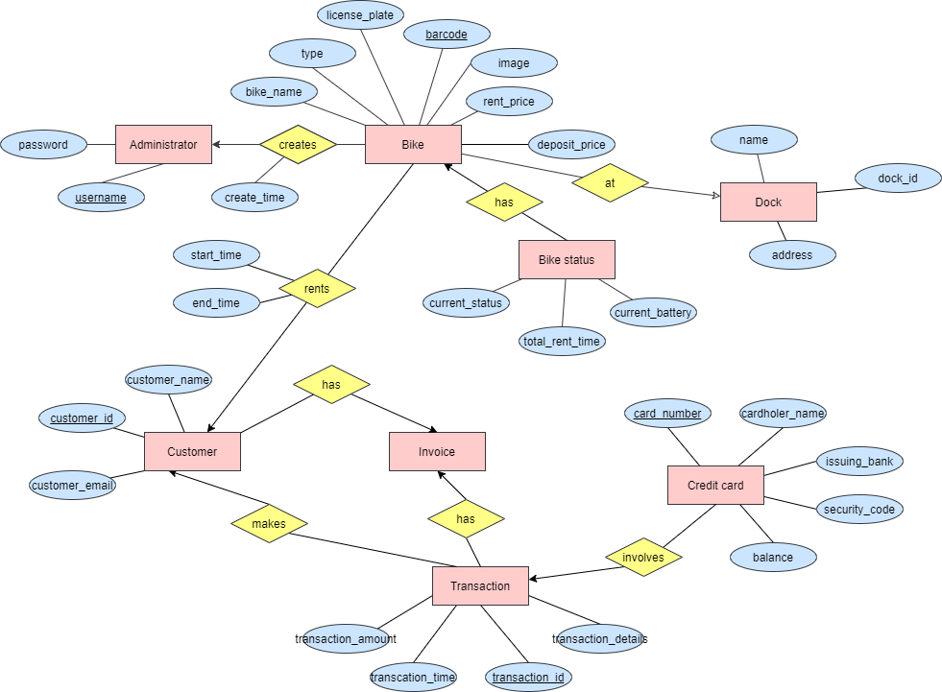

1. **Table relationships**

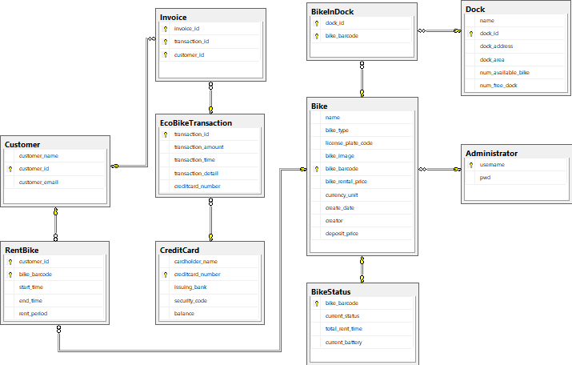

1. **Table specifications**

**Invoice**

|  |  |  |  |  |  |  |
| --- | --- | --- | --- | --- | --- | --- |
| **No.** | **PK** | **FK** | **Name** | **Data type** | **Mandatory** | **Description** |
| 1 | x |  | invoice_id | int | X | ID of the invoice |
| 2 |  | x | transaction_id | int | x | ID of the transaction |
| 3 |  | x | customer_id | int | x | ID of the customer |

## **EcoBikeTransaction**

|  |  |  |  |  |  |  |
| --- | --- | --- | --- | --- | --- | --- |
| **No.** | **PK** | **FK** | **Name** | **Data type** | **Mandatory** | **Description** |
| 1 | x |  | transaction_id | int | x | ID of transaction |
| 2 |  |  | transaction_amount | int | x | The amount of money for the transaction |
| 3 |  |  | transaction_time | DATETIME | x | Time the transaction is made |
| 4 |  |  | transaction_detail | varchar(256) |  | The content of the transaction |
| 5 |  | x | creditcard_number | int | x | The number of the credit card |